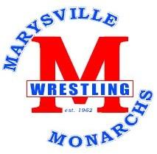

By signing below I am acknowledging that I have read both the Marysville Athletic code of conduct and the Marysville Wrestling handbook, and agree to the rules and expectations of being a member of the wrestling team.
Wrestler Parent

Date ______________ Date _________________

A link to both of these documents can be found at
http://www.marysville.k12.oh.us/mhs/athletics/wrestling/

Any questions please e-mail or call Coach Andrews
scandrew@marysville.k12.oh.us 937.243.1911

